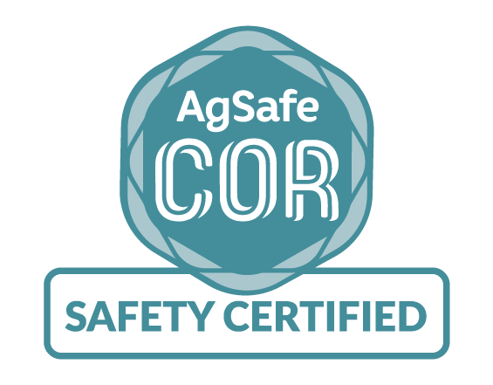
SMALL EMPLOYER
GAP Analysis Summary
2017
Advisor’s Name:
Company Name:
Date:

COR Program Introduction

The Certificate of Recognition Program is an incentive program that recognizes and rewards employers for implementing effective Occupational Health and Safety (OHS) programs that demonstrate commitment to workplace health and safety. Participation in the program is voluntary.

Employers who successfully complete an Occupational Health and Safety program audit receive an incentive payment of up to 10% of the base assessment premiums paid to WorkSafeBC in the prior year.

GAP Scope

The GAP Analysis is a snapshot in time, using representative sampling of documentation to identify elements of the program where opportunity exists to reduce or eliminate injuries. The GAP Analysis is only representative of a document review and does not include interviews or a survey.

Executive Summary

Summary of Overall Strengths

Summary of Key Recommendations

Executive Summary

Conclusion

Advisor’s Comments
AgSafe has in the field professionals available to assist in developing your health and safety program. Let us guide you through this process to COR certification, a WorkSafeBC rebate check and eliminating injuries.

