Company Information
Company Name:
Workplace Location:
Name of Safe Work Practice: |  |  |  |  |  | ATV/UTV - Cranberry |  |  | Release Date:
Safe Work Practice #: |  |  |  |  |  |  |  |  | Revision Date:
Management Signature: |  |  |  |  |  |  |  |  | Date of Approval:
Instructions
This safe work practice must be reviewed annually or any time the task, equipment, or materials change.
Do NOT perform the duties listed in this Safe Work Practice until you have been appropriately trained and authorized to do so by your supervisor
Required Training: |  | Pre-operation inspection. Use of personal protective apparel. Operating skills according to manufacturers requirements including performing a documented operation competency evaluation. Basic mechanical requirements. Safe refueling procedures. Loading and unloading (if this task is required). Safe use of winches (if equipped). Working alone or in isolation procedures (if required).
Required Personal Protective Equipment and Devices:
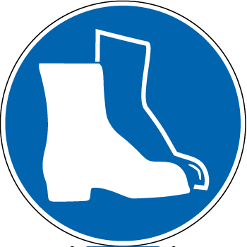 | CSA Approved Safety Footwear Required |  |  |  |  |  | 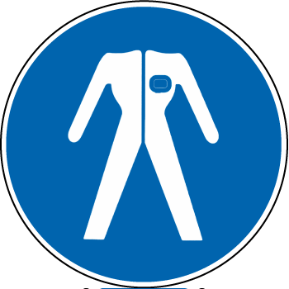 | Protective Clothing Required.  - CSA approved helmet with chinstrap done up must be worn while operating an ATV.  - Pants and long sleeve shirts.  - Other protective clothing may be required for weather conditions.
 | Hearing Protection Required
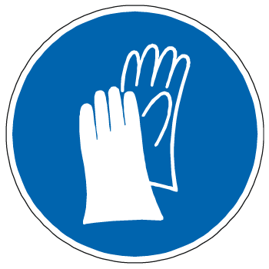 | No loose-fitting clothing
 |  |  |  |  |  |  |  | No loose-fitting clothing
Potential Hazards:
Pre-Operational Safety Checks:
- Use the ATV / UTV pre operation inspection form or book to conduct your inspection.
- Ensure the vehicle is in good working order. Do not operate a machine that does not pass the inspection. Report any deficiencies to a supervisor before starting the machine.
- Check tire pressure/ track condition. Check fuel and oil levels and secure any external fuel tanks. Check that brakes, clutch and throttle move freely. Check lights. Inspect for ice or mud build-up around the brakes and throttle. Check seatbelt condition and operation (UTV only). Inspect all PPE prior to use. Ensure toolkit is on board and extra spark plug.
- Secure any cargo prior to starting.
- Use a checklist from the manufacturer to ensure all items required are on your personalized checklist.

Safe Work Practice
Before you Start
- Inspect required personal protective equipment and replace if required.
- Put on all required personal protective equipment.
Loading and unloading
- Ramps must be placed at a suitable angle, be sufficiently wide and have a surface finish which provides an adequate grip for the tires/tracks. The ramp must meet the weight specifications of the machine.
- Ramps must be secured in place with tie-down straps prior to use.
- Ensure the loading / unloading area is clear of obstacles.
- Be confident in your abilities and do not load or unload if you do not feel comfortable.
- Ensure the machines and ramps are secured properly for transportation.
Operating
- Always be cautious when operating an ATV or UTV, especially when approaching hills, turns or obstacles and when operating on unfamiliar or rough terrain.
- For ATVs, only one person is allowed per machine. Doubling is not permitted unless the machine is equipped with a manufacturer’s passenger seat. For UTV’s only one operator and one passenger is permitted unless the machine is a four-seater. Each occupant of a UTV must wear a seat belt. Passengers must not interfere or distract the driver.
- Avoid excessive speeds. Travel at a speed appropriate for the terrain, visibility conditions and your level of experience.
- Operate within slope limits (up, down, and cross slope) as set by the manufacturer. These are the maximum allowable slopes the unit can be operated on.
- Operate the machine only to the extent of your personal comfort level and be aware of your surroundings.
If an emergency situation occurs while conducting this task, or there is an equipment malfunction, shut the equipment off immediately and follow the lock out procedure.
REPORT ANY HAZARDOUS SITUATION TO YOUR SUPERVISOR/MANAGER OR EMPLOYER IMMEDIATELY

