Tailgate, Hitching Rail, Tool Box Talks
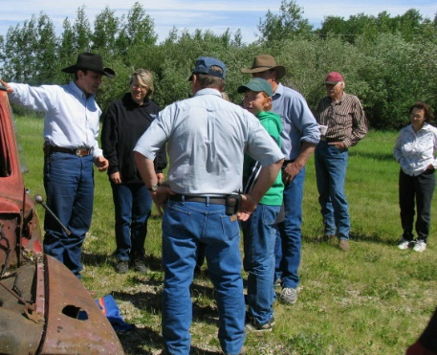
You have heard or seen references to these types of training sessions and informational sharing times over the years. Perhaps you heard of them from an inspection order, a previous or alternate work environment, AgSafe materials and field consultations or self-discovery. So, what are these and how do you make them a valuable use of the precious commodity of time.

There are several long standing and established methods and concepts for conducting such mini meetings. This is great because long and standing in our ever-changing world are two words not often seen together anymore and if found together they are usually utilized in a negative context. So, for some of us older dogs who like to see the same bone and chew on it more than once it is refreshing to have some things stay the same.

Here are some helpful tips to conducting these times with your crew or family to make them an important and valuable part of your establishment of a culture of safety at your ranch. These meetings should be conducted at least weekly and must also be done whenever there is a change in a work practice or environment, or if there is need to clarify tasks, assignments and procedures.

They do not replace training, orientation or education of workers but they provide supplemental information. The information you supply in a toolbox, tailgate, hitching rail meeting should only take about 10-15 minutes, but it must be documented. Consider it a valuable time for your crew to discuss issues, provide feedback and solutions to you and to learn from each other. So how best to do these?
Choose only one topic per session:
This provides clarity and keeps the meeting targeted and focused. Make it something that actually pertains to the interests and work required of your crew.
Be Concise. Keep it short:
This is not a time to entertain the troops or cut deeply into the time allocated for the various ongoing tasks of the day. Stay on topic, keep it short, use some notes to keep you on topic.
Keep the sessions small:
With most crews and ranches this is not a challenge but if you have a larger staff or a combined work force segment the group into appropriate and like task members of your crew.
Meet in a comfortable location:
If you meet in a bitter wind, stand in a snowbank or gather under a blazing sun your crew will lose focus and attention and count the moments until “this thing is done.”

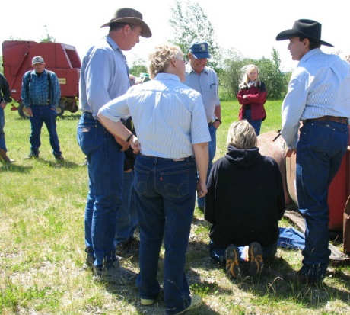
The simple concept of a tailgate, hitching rail or toolbox talk is to assemble a small group of workers, family, helpers in a comfortable place for a brief training session on a single safety topic. Limit the session to no more than 10 workers, if you have more break up the dates of your meetings with them, the topics pertinent to various ones within a larger group or by worker experience. Choose an appropriate, easy to get to and away from site that considers the comfort of the worker and if possible and of value at the site of the training you are undertaking. Try to hold your sessions early in the week, there is a much better chance that they will consistently get done before the business of thee week presses in on you, the crew, and the things that need to be done.

To help keep your time short set a predetermined period of time and stick to it. Don’t be afraid to let a subject matter expert use the time such as your cow boss or the visiting machine sales person dropping off the new baler. The records of your recent injuries, incidents and challenges at your specific site will help you to choose the topic and will make the topic relevant. Consider during the week the things that you would like to address. Take mental notes as you work around your ranch, check the machinery and observe worker habits and practices with a view to providing direction at your next meeting. Ask employees for their input, their ideas are usually very practical and applicable to what is really going on. Provide a place for them to make suggestions for training and information sharing, a white board or a binder.

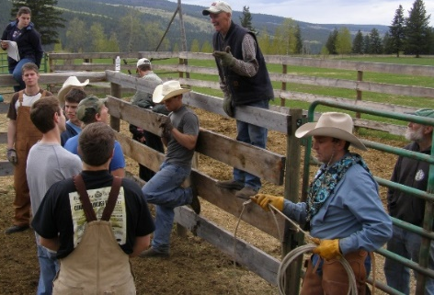
It is important to prepare, use a one-page fact sheet or outline of your own ideas. Visual aids can be a great help, a piece of tack, a tool or other equipment, a piece of personal protective equipment are among those things that can be helpful in creating an effective teaching point. If you have handouts prepare them before your quick meeting, if you are introducing new signage or directives make sure that you have examples of such materials for reference or handout. Part of being prepared will require that you know the topic, you do not have to be a subject matter expert but when sharing you should have previewed and read the material prior to presenting it to your meeting.
Other key points to making this time of value to all who will be in attendance include:
- Keep it casual, make the presentation informal
- Allow input, questions and answers, involve your workers in the discussion
- Don’t use words, terms or language that your workers will not understand
- Have employees sign a sheet acknowledging that they received training and keep this on file.

For any help with topics, materials from which to work or other assistance in this method of training that is valuable, succinct and in many circumstances required, contact your regional AgSafe safety consultant at
1-877-533-1789 toll free.

